16.
Benefits of CLC:
- Different environment types are clearly classified and easily interpretable.
- Extends far into Europe
- Can work to corroborate satellite imagery analyses
Limitations of CLC:
- Categories are very broad and can lump very different surfaces into the same category. These three points appear very differently in the NIR false color composite but are the same category in the CLC classification.
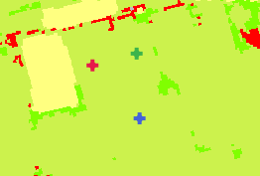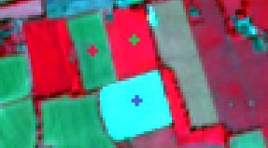
The spectral profiles are also very different.
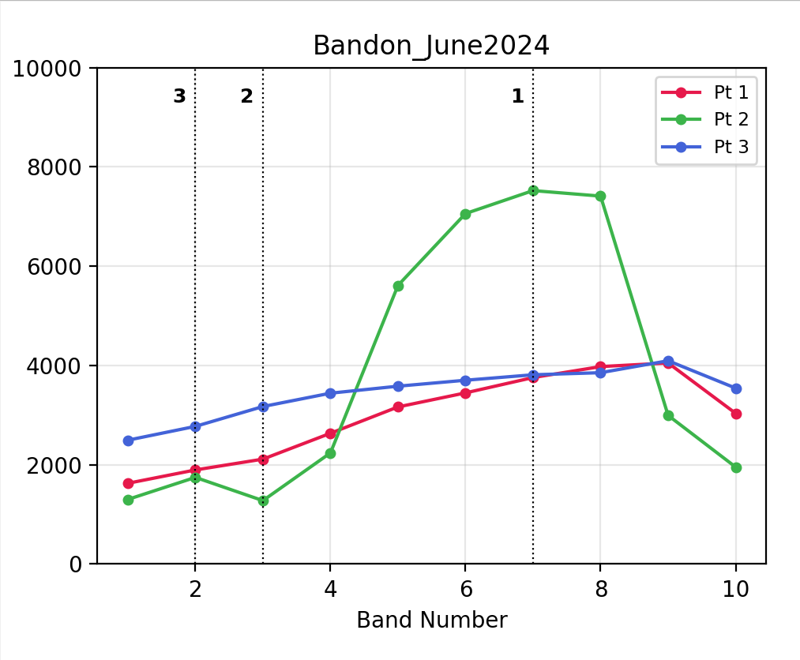
- Unable to see levels of reflectance across different bands so detail is lost.
- This extends to areas of water too that are all grouped together
